s2. . Develop a Java program to create a class Student with members usn, name an array credits and an array marks. Include methods to accept and displaydetails and a method to calculate SGPA of a student. . Develop a Java program to create a class Student with members usn, name,  
an array credits and an array marks. Include methods to accept and display  
details and a method to calculate SGPA of a student.

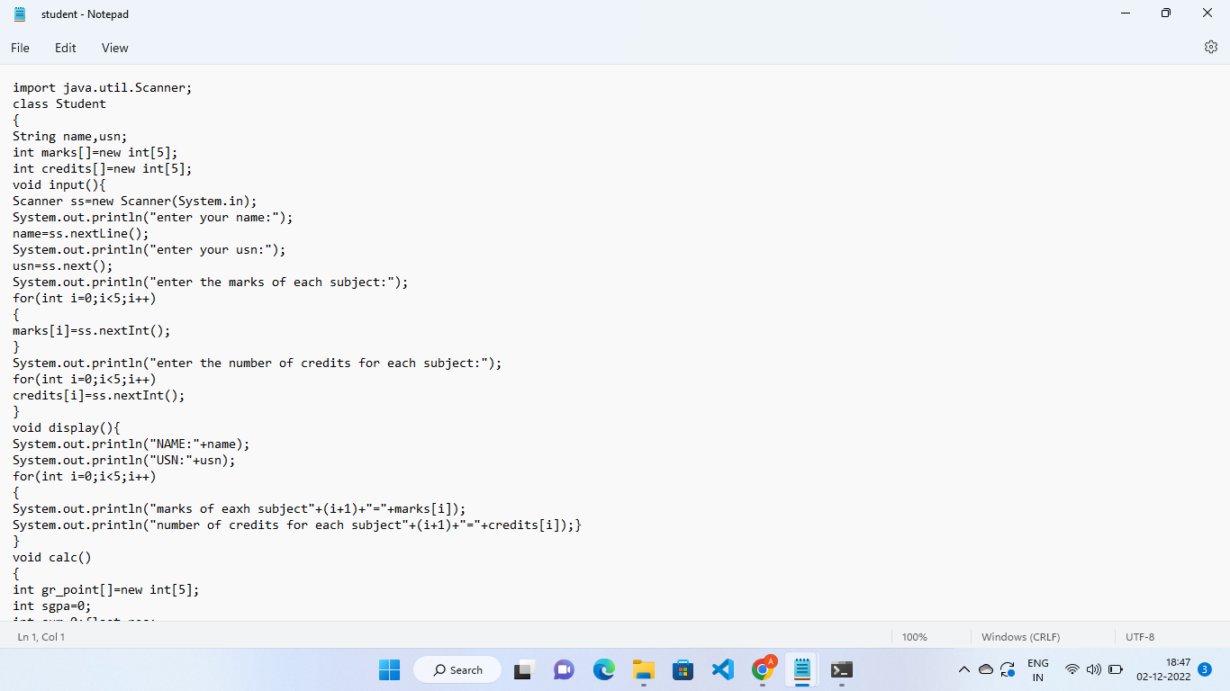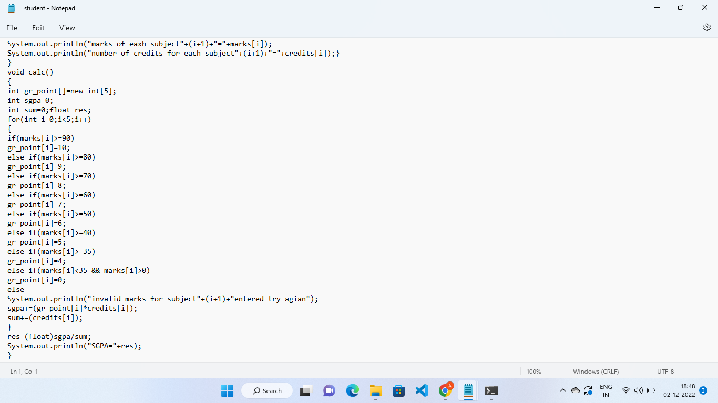

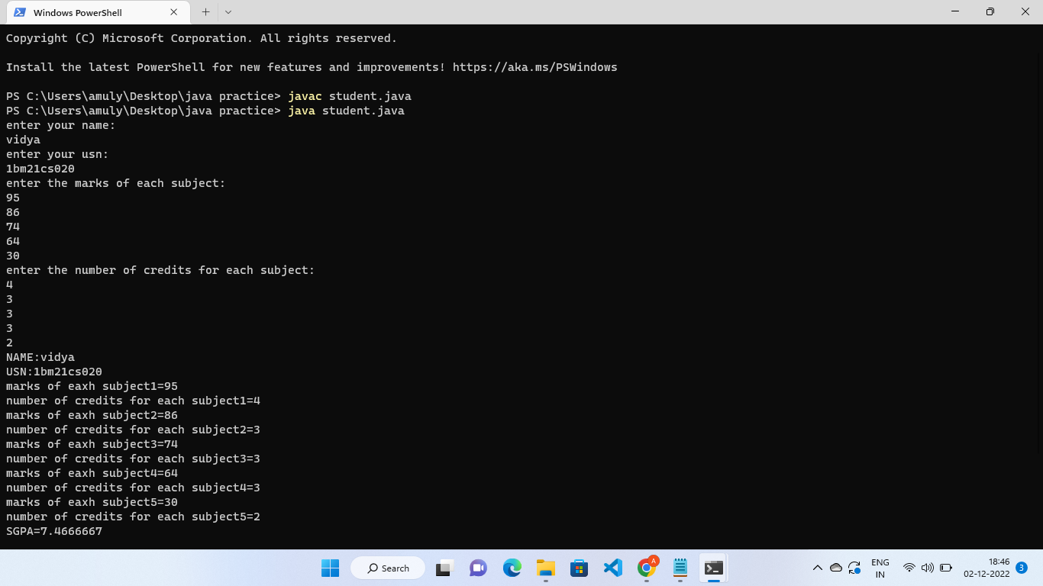

Create a class Book which contains four members: name, author, price,  
num_pages. Include a constructor to set the values for the members. Include  
methods to set and get the details of the objects. Include a toString( ) method  
that could display the complete details of the book. Develop a Java program  
to create n book objects.

